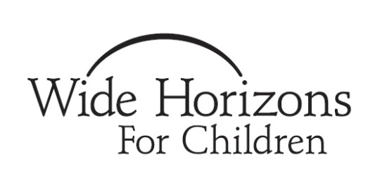
WHFC Pre-Adoption Education:

PHASE 1 – INTERNATIONAL (PS)PROGRAMS

WHFC’s Pre-Adoption Educational Curriculum has been developed, in compliance with the provisions of the Hague Treaty, to provide families with an understanding of adoption, to assist families in decision making during the process, and to maximize the success families and children experience in adoption. Thus, the information and resources provided will help place children with families who are prepared and able to meet their needs.
Your Pre-Adoption Education will encompass three phases. This First Phase will provide general education that must be completed prior to your final home study visit with your social worker. A Second Phase will be completed after you have applied to your Program but before you accept a referral of a child. At that time you will know a bit more about the child you are planning to adopt – the country he or she will be from, the possible age he or she will be, and possibly whether he or she will have any specific known medical issues. Thus, the second phase of pre-adoption education will focus on providing information more specific to your path of adoption. Finally, the Third Phase of education will be completed after you have received a referral of a child but before you travel. By then you will have many more details about your child and the focus will be on preparing for your specific child and his or her needs.
For Phase 1, the modes of education include literature, on-site seminars, and online courses. Courses and materials are available directly through WHFC and through other qualified providers noted. Applicants should document their participation on the enclosed "Menu of Pre-Adoption Education." The completed menu, along with any certification of completions, must be submitted to conclude your home study documentation.
For couples, both members need to fulfill all requirements.
Costs noted are subject to change.
Initial Steps To Take:
_____1. Order the book “The Connected Child: Bring Hope and Healing to your Adoptive Family” by Karyn B Purvis, David R Cross et al.
_____2. Request the WHFC “Program Papers” for any countries of interest. These are detailed documents that introduce you to the particular country’s adoption program. Topics covered include the adoption process, eligibility requirements, the general characteristic & needs of children available for adoption, and the in-country conditions that affect children. The program papers are multi-page documents titled “Adopting a Child from…” and can be requested from a representative of that country’s program.
____3. Discuss with your program manager your plan for pre-adoption education to make sure all requirements are being met.

NOTE: Families who have adopted before may be exempted from some or all of the requirements based on how long ago the last adoption occurred, what pre-adopt education was completed at that time and whether the age of child and program are different from those of the previous adoption. If you feel you are eligible for an exemption, please contact Maryanne Ludwig (Director of Family Services) to discuss. She can be reached at 781-419-0345 or mludwig@whfc.org.

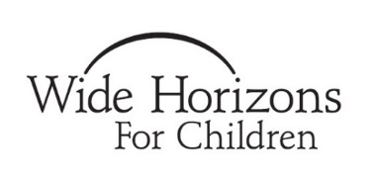
WHFC MENU OF Pre-Adoption Education
PHASE 1 – INTERNATIONAL (PS) PROGRAMS
Item | Hours | Date of Completion/ Certificate Provided
Option I: Adoption Preparation Seminar

If your local agency or another local resource provides a pre-adoption education class, please provide the following information:

Date of Class:___________________________
Hosted By:_____________________________
The class includes information about: (check all that apply)
- Adjustment and Attachment of children post adoption
- Impact of institutionalization or foster care on children
- Impact of Trauma on children
- Possible struggles children will have related to these issues
- Parenting techniques to make adoption successful
Fulfills regulations 96.48 (b) (3, 4, 5 & 7)
Option II: Online Adoption Preparation Seminars  If your local agency or another local resource does not provide a pre-adoption education class, please take the following classes at www.adoptionlearningpartners.org  The Journey of Attachment  Finding the Missing Pieces  With Eyes Wide Open  Fulfills regulations 96.48 (b) (3, 4, 5 & 7) | 2  2  4
Online course: Race and Culture  Heart of the Matter Education www.heartofthemattereducation.com  Fulfills regulations 96.48 (b) (7); 96.48 (c) (1) | 1
Online course: Medical Issues in International Adoption  Adoption Learning Partners www.adoptionlearningpartners.org  Fulfills regulations 96.48 (b) (2); 96.48 (c) (2) | 2.5
Reading: Program specific documents, “Adopting a Child from…” and return Country Specific Service Plan Addendum  Fulfills regulations 96.44 (a); 96.48 (b) (1,2,4, 6, & 8); 96.48 (c) (2) | .5
Reading: “The Connected Child: Bring Hope and Healing to Your Adoptive Family” by Karyn B Purvis, David R Cross, et al  Fulfills regulations 96.48 (b) (3, 4, 5, & 7) | 3
If not adopting an older child, complete WHFC Toddler Worksheets
Fulfills regulation 96.48 (c) (3)
Completed by WHFC Staff Only: Please note any waivers or additional courses:

Total Hours

Additional requirements for families adopting a child who will likely arrive home at 5 or older:
Online course: Adopting The Older Child  Adoption Learning Partners www.adoptionlearningpartners.org  Fulfills regulations 96.48 (b) (3 & 4); 96.48 (c); 96.48 (e) | 2
Complete WHFC Older Child Workbook
Fulfills regulations 96.48 (c) (1 & 3)

Additional requirements for families pursuing a special needs adoption:
Online course: Parent planning for Special Needs Adoption  Heart of the Matter Education www.heartofthemattereducation.com  Fulfills regulations 96.48 (c) (3); 96.48 (e) | 2
Complete reference calls to adoptive families

The Following Family has Completed Phase 1 of the WHFC Pre-Adoption Education Curriculum

Family Name: _______________________________________________________________

Agency signature: _______________________________ Date: ________________

