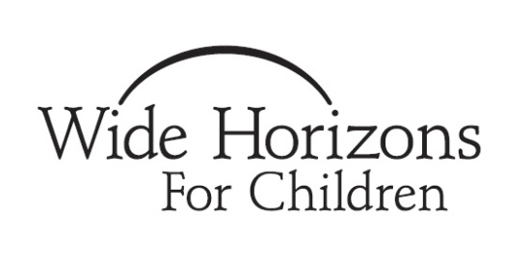
WHFC Pre-Adoption Education:

EDUCATION REQUIREMENTS

While much of parenting through adoption is simply parenting, there are some unique facets of becoming a family through adoption. WHFC is committed to your and your future child’s health and well-being. A component of this is helping you prepare as completely as possible for the adoption process and for parenting through adoption. Our pre-adoption education curriculum focuses on several key areas including the impact of prenatal and early environments, loss and grief in children, early adjustments of children and families, birth families, talking about adoption, and racial identity.

WHFC currently requires greater than 10 hours of education for pre-adoptive parents to provide you with a well-rounded education and to demonstrate compliance with the Hague Convention on Intercountry Adoption (if applicable). You will meet these requirements through a combination of readings, on-line courses, and seminars that are completed at different stages of your process. Your social worker will review Phase 1 of the education requirements in his or her first meeting with you. Education requirements differ slightly based on the types of adoption being explored – international, domestic, older child, and/or special needs. International Adoptions require additional Phases of education that your Program Manager will review with you after your home study.

As part of the Phase 1 requirement, all families must take a 6 hour pre-adoption education group at our NY office or an 8 hour session offered at our MA office or in NH. The MA and NH classes have an additional charge of $125 per person.

If you are married or adopting with a partner, both of you must attend.
If you have adopted through WHFC before and attended this group within the past three years, you do not have to attend again.

WHFC clients are welcome to attend groups in any location regardless of state of residence. However, NH families must attend the 8 hour course in NH or MA due to state regulations.

The schedule for the NH and MA classes is available in the document titled “Adoption Preparation Seminar Schedule.” The NY classes are scheduled as needed. Please consult your social worker for dates.

